**Speed Control of DC Motor**

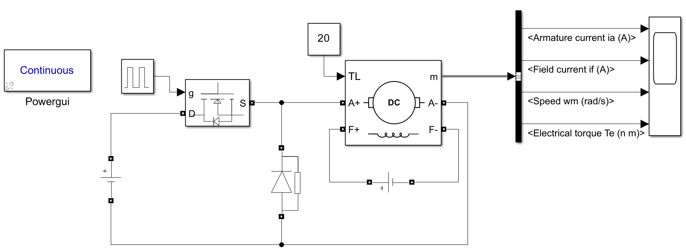

**Fig. Block Diagram of Speed Control of DC Motor**



**Fig. Characteristics of Speed Control of DC Motor**